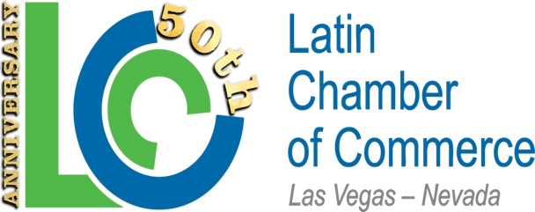
LCC 2026 Endorsements
Constitutional
Governor Joe Lombardo
Secretary of State Cisco Aguilar
Andy Mathews Controller

Law Enforcement
Sheriff Kevin McMahill

Municipal
Mayor Michelle Romero
Scott Black for Mayor
County Commissioner DG Jim Gibson
County Commission DF Heidi Kasama
NLV Councilwoman Esmeralda Villeda
Luke McCarthy City Council Ward 2

Board of Regents
Moises Dennis
CCSD Board
Irene Bustamante Adams DF

State Senate-NV
Rafael Arroyo SD 12
Lisa Krasner SD16
Robin Titus SD17
Danielle Gallant SD20

Assembly-NV
Rebecca Edgeworth AD35
Lisa Cole AD4
Jason Patchett AD19
Melissa Hardy AD22
Denise Fanning AD23
Rich Delong AD26
Jill Dickman AD31
Gregory Hafen AD36
Jill Douglas AD37
Gregory Koenig AD38
Brian Hibbits AD13
Kelly Chapman AD41
Erica Neely AD9
Selena Torres-Fossett AD3
Erica Mosca AD14
Venicia Considine AD18
Elaine Marzola AD21
Cinthia Moore AD11

